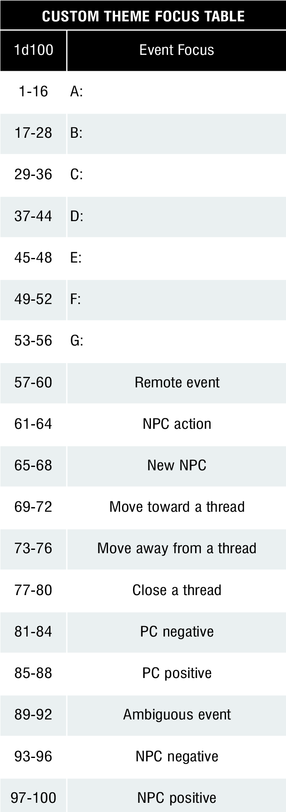

Player attacked by 1 giant frog

Player attacked by 4 bullywug croakers

Player attacked by 1 bullywug twitcher

Player attacked by 3 bullywug muckers

Player attacked by 2 bullywug twitchers

Player attacked by 2 bullywug muckers

Player attacked by 2 bullywug croakers